CUSTOMER DATA ANALYSIS REPORT

Name: chilakala swathi
Course: CDA

Introduction
This project focuses on analyzing customer shopping behavior using Power BI. The dataset contains customer transaction information such as gender, age, product category, quantity, payment method, shopping mall, invoice date, and total sales.

Objective
The objective of this project is to analyze customer purchasing patterns and generate business insights using interactive dashboards and visualizations in Power BI

Data cleaning and transformation
The dataset was connected from MYSQL workbench to Power BI for analysis. Data cleaning and transformation were performed using Power Query. Data types were corrected, null values were checked, duplicate values were analyzed, and a total sales column was created for analysis.

DAX Measures
DAX (data analysis expressions) measures were created in Power BI to calculate important business metrics used in the dashboard.
Examples of DAX measures used in the project:
Total sales = SUM(Fact_sales[total_sales])
Total orders = COUNT(Fact_sales[invoice_no])
Total customers = DISTINCTCOUNT(Dim_Customer[customer_id])
These measures were used in KPI cards and dashboard visualizations for analysis.

Data Modeling
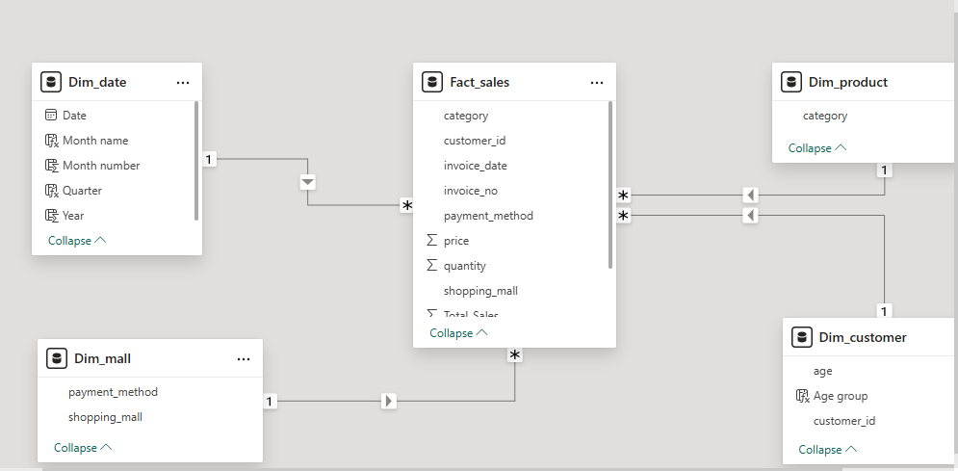
The data model was created using a star schema approach. Fact_sales was connected with dimension tables such as Dim_customer, Dim_product, Dim_mall, and Dim_date using relationships in Power BI.

Dashboard Analysis
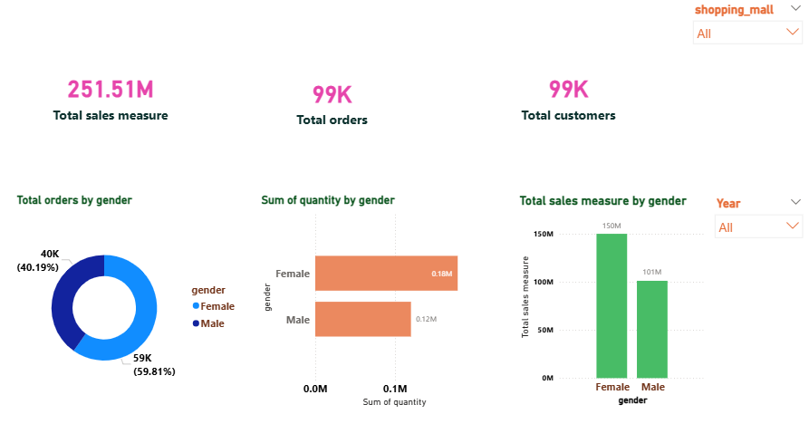
The above dashboard page focuses on gender-based customer shopping analysis. KPI cards display total sales measure, total orders, and total customers. Visualizations were created to analyse shopping distribution, revenue contribution and product purchases based on gender.

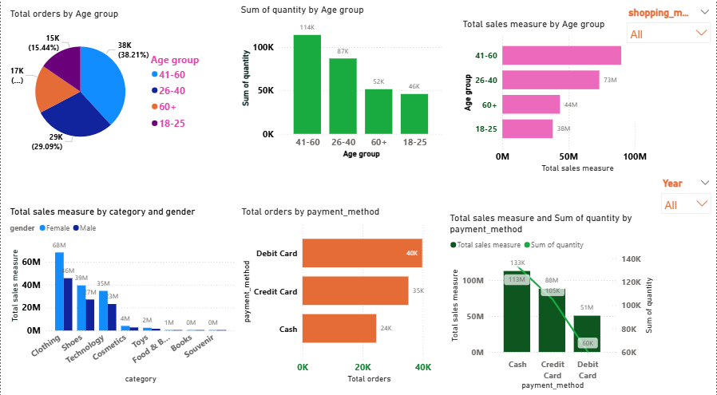
The above dashboard page focuses on age group analysis, category analysis, and payment method analysis. Different visualizations were used to analyse customer purchasing patterns, revenue distribution, and payment preferences.

Key Insights
- Female customers contributed a significant portion of total sales revenue.
- Customers aged 26-40 generated higher revenue.
- Clothing category showed strong sales performance.
- Credit card and cash were the most commonly used payment methods.
- Shopping behaviour varied across shopping malls and years.

Recommendations
- The company can focus more on high-performing product categories to increase sales.
- Marketing strategies can be improved based on customer age groups and gender.
- Customer payment preferences can help improve shopping experience.
- Promotional offers can be introduced in shopping malls with lower sales.

conclusion
the project successfully analysed customer purchasing behaviour using Power BI dash board and visualizations. The generated insights can help businesses understand customer preferences and improve business decision-making.

